YPD Career Vision Program
CVP Lite™ - Dashboard UI

Student Dashboard (Left Pane)
[≡] CVP Lite™ – Student Panel
├─ Student Profile (Editable/Review)
• Name
• Grade
• City
• Favorite Subjects
• Hobbies & Interests
• Aspirational Careers
• Strengths
• Weaknesses
• Extracurriculars
• Future Goal
├─ Key Guidelines
• Step-locked flow (no skipping)
• Journals mandatory in certain steps
• Scores revealed only in the Final Report
├─ Privacy & Consent
• Consent status & data policy
├─ Help / Contact
• Support link (Email/Chat)
└─ Upgrade Info (View-only nudges)
• “For deeper career mapping, explore CVP Advance/Challenger.”

CENTER PANE (Fixed Assessment Container)
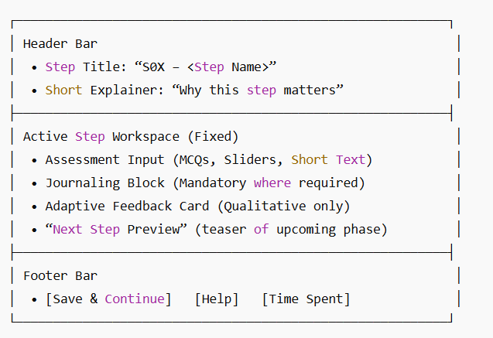

RIGHT PANE (Progress + Detailed Journey Tree)
[▶] Journey Tracker — CVP Lite™

Overall Progress:
[██████░░░░] 55% Complete (Steps Completed: 6/11)

Phase A — Setup
├─ S01: Profile Setup
• Status: Completed
└─ S02: Interest & Strengths Discovery
• Status: Completed
• Journal: ✅ (200 words filled)

Phase B — Core Assessments
├─ S03: Values & Work Preferences
• Status: Completed
• Journal: ✅ (150 words)
├─ S04: Learning Style + Personality
• Status: Completed
• Journal: ✅ (180 words)
├─ S05: Passion–Career Alignment
• Status: In Progress
• Journal: ❗ (Incomplete)

Phase C — Cognitive & Emotional Assessment
├─ S06: Cognitive Problem-Solving
• Status: Locked (Complete S05 first)
├─ S07: Emotional Intelligence & Ethics
• Status: Locked

Phase D — Synthesis & Education Pathways
├─ S08: Career Direction Synthesis
• Status: Locked
├─ S09: Education Pathway Guidance
• Status: Locked

Phase E — Action & Final Report
├─ S10: Personal Action Planning
• Status: Locked
└─ S11: Completion & Report Generation
• Status: Locked

